 |  |  |  |  | Company Confidential
January 2007 | - |  | Ver. 0.1 |  |  | Datasheet

RF Receiver GMR

Company Confidential

ChipIdea® Microelectrónica, S.A.
TagusPark, Avenida Dr. Mário Soares Lote 21
2740-119 Porto Salvo, Portugal
Tel.: (+351) 210336300
Fax: (+351) 210336396
http://www.chipidea.com
© 2006 Copyright ChipIdea
ChipIdea Microelectrónica, S.A. reserves the right to make changes to the information contained herein without notice. No liability shall be incurred as a result of its use or application.

Table of Contents

RF Receiver GMR 1
1. Features 3
2. General Description 3
3. Functional Diagram 3
4. Circuit Description 4
External Components and connection to the Baseband IC 4
Choice of Low-IF 5
Power-Saving Modes 5
5. Electrical specification 6
Temperature Ranges 6
System Supplies 6
Logic Input & Output Signals 6
Power Saving Modes 6
Receiver 6
Synthesizer 7
Crystal Oscillator / TCXO Buffer 7
Serial Interface 7
6. Pinout 8

Features | General Description
- L-band receiver for GMR  - Low-IF architecture  - LNA included  - Low External Component Count  - Fully Integrated Fractional-N RF Synthesizer  - Supports different reference frequencies  - Multiple Power-Saving Modes  - Single supply: 1.8V  - Integrated regulators for analog supply  - Consumption: 19 mA (15 mA w/o LNA)  - Chip Area (with IOs): 4 mm² | This chip is an integrated low-noise RF receiver for GMR in L-band from 1525 to 1559 MHz.  It is designed to work with a base-band IC with embedded ADC. Uses a Low-IF architecture.  The Fractional-N synthesizer provides a very flexible frequency plan, supporting a wide range of crystal oscillators.  System control and status monitoring over a serial interface.  Optimized for low power consumption, uses few and low-cost external components and is instantiated in 0.18um CMOS process.

Functional Diagram
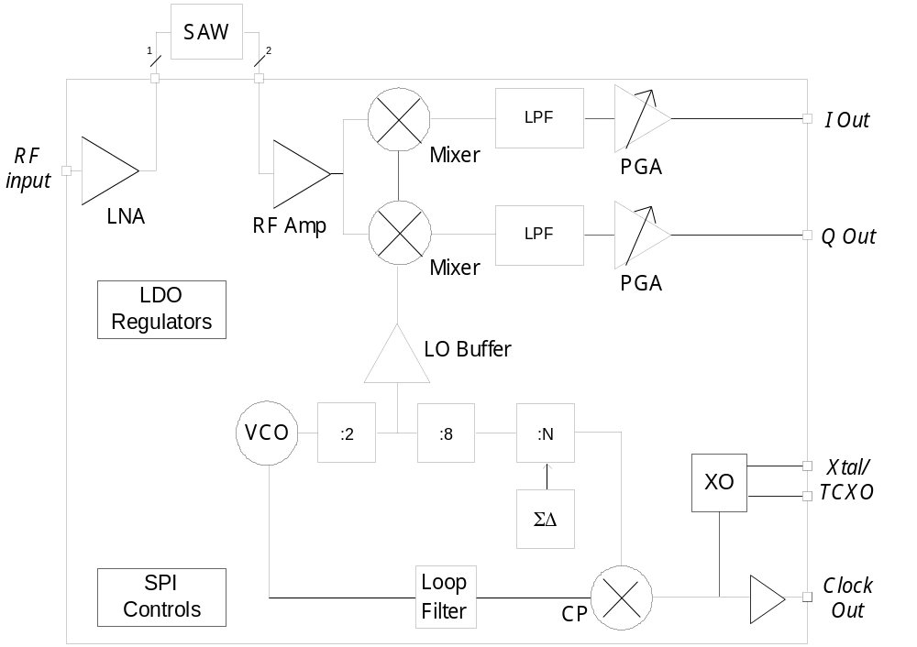

Circuit Description
This chip is an integrated low-noise and low-power RF Receiver for GEO (Geostationary Earth Orbit) Mobile Radio (GMR) in the L-band. It is designed to work with a baseband IC with embedded ADCs and supports a wide range of crystal frequencies.
The architecture uses a low-IF frequency. The input signal is in the band 1525-1559 MHz. This signal is amplified by a single-ended LNA and then fed to an external SAW filter with 50 Ω input impedance. The SAW filter has a 100Ω differential output. Except for the LNA, the entire receiver is differential to improve immunity to substrate and supply disturbances.
An input adapted RF amplifier compensates for the losses in the SAW filter, thus relaxing the NF requirements for the I and Q mixers.
After down-conversion the I and Q signals are lowpass-filtered to eliminate out-of-band jammers. AC coupling eliminates residual offset from the down-conversion mixers.
Next is a PGA with a gain range of 48 dB with steps of 3dB. The PGA is controlled through the SPI. The output of the chip is differential.
The VCO is running at double the mixer-LO frequency, and the two quadrature LO signals are obtained with a divider-by-two. The synthesizer is a high-resolution fractional-N allowing a very flexible frequency plan, with a resolution of better than 1 kHz. Therefore, it is possible to share the same crystal with the host application, such as in a mobile phone. A crystal oscillator is also included for stand-alone applications.

External Components and connection to the Baseband IC

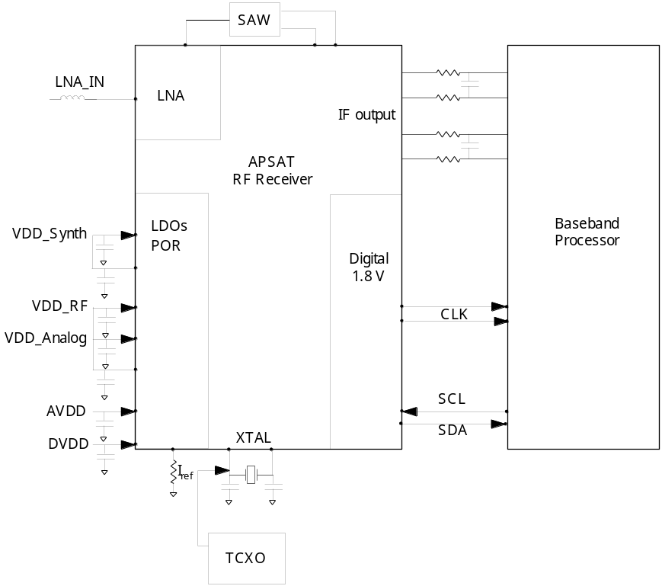
There are very few external components due to the Low-IF architecture. Also the Synthesizer loop filter is on-chip.
The external components are the SAW filter, the crystal and associated capacitors, supply decoupling capacitors and a resistor for setting bias.
The LNA input needs an inductor for impedance matching. This allows for adapting to different packages.
The SAW must be centered on the 1542 MHz band, have a single-ended input at 50 Ohm and a differential output at 100 Ohm.
The connection to baseband includes RC filtering to remove adjacent channels. For minimizing I&Q mismatches, these components should be 1% tolerance.

Choice of Low-IF

The channel to receive has a 31.25 kHz bandwidth. The minimum Low-IF frequency is about 100 kHz due to the internal AC coupling. A possible Low-IF frequency could then be 100 kHz, meaning that the Frequency Synthesizer needs to be tuned 100 kHz above the channel center frequency. The external RC lowpass filter should then be designed with a cut-off frequency at about 150 kHz, in order not to introduce too much droop and group delay variation within the passband.

Power-Saving Modes

The chip has four major operating modes controlled through the serial interface.
- Sleep Mode: in this mode all analog blocks including all reference voltage and current blocks are OFF. Therefore, recovering from this mode takes a long time.
- Doze Mode: in this mode, the XO, references and LDOs are running to enable fast wake-up. The receiver and frequency synthesizer are OFF.
- Stand-by Mode: in this mode, the signal path blocks are OFF but all the rest, including the frequency synthesizer, is running to enable very fast wake-up.
- Fully Active Mode: in this mode, the complete receiver is active.

Electrical specification

Temperature Ranges
Parameter | Conditions | Min | Typ | Max | Unit
Ambient Temperature, TA |  | - 40 |  | + 85 | C
Junction Temperature, TJ | For functional chip | - 40 |  | + 125 | C
Junction Temperature, TJ | For full-spec | -20 |  | + 70 | C
Storage Temperature |  | - 40 |  | + 150 | C

System Supplies
Parameter | Conditions | Min | Typ | Max | Unit
Digital and IO Power Supply | On DVDD and DVDDIO | 1.75 | 1.8 | 2.0 | V
Analog Core Power Supply | On AVDD | 1.75 | 1.8 | 2.0 | V

Logic Input & Output Signals
Parameter | Conditions | Min | Typ | Max | Unit
VIH High Level Input Voltage |  | 0.7*DVDD |  | DVDD+0.3 | V
VIL Low Level Input Voltage |  | - 0.3 |  | 0.3*DVDD | V
VOH High Level Output Voltage |  | 0.8*DVDD |  | DVDD | V
VOL Low Level Output Voltage |  | 0 |  | 0.2*DVDD | V

Power Saving Modes
Parameter | Conditions | Min | Typ | Max | Unit
Wake-Up Time from Sleep |  |  |  | 5 | ms
Wake-up from Doze |  |  |  | 900 | us
Wake-up Time from Stand-By |  |  |  | 10 | us
Consumption in Sleep Mode |  |  |  | 10 | uA
Consumption in Doze Mode |  |  |  | 2 | mA
Consumption in Stand-by Mode |  |  |  | 10 | mA
Consumption in Fully-Active Mode | LNA OFF |  |  | 15 | mA
Consumption in Fully-Active Mode | LNA ON |  |  | 19 | mA

Receiver
Parameter | Conditions | Min | Typ | Max | Unit
Receiver Input Frequency |  | 1525 | 1542 | 1559 | MHz
Receiver NF |  |  | 2.5 | 3 | dB
RF input impedance | LNA (single ended) |  | 50 |  | Ω
RF input impedance | Mixer (differential) |  | 100 |  | Ω
Input Return Loss (S₁₁) | LNA (single ended) |  | -12 | -9 | dB
Input Return Loss (S₁₁) | RF Amplifer (differential) |  | -12 | -9 | dB
LNA IIP3 | @1920 MHz |  | 0 |  | dBm
SAW Filter Insertion Loss |  |  | 1.6 | 2 | dB
RF Amplifier IIP3 |  |  | -25 |  | dBm
Gain | LNA (power gain)  RF Amp  PGA (step size 3 dB) | 27 | 16  16 | 81 | dB  dB  dB
LPF (3rd order) | Cut-off frequency  In-band ripple  Rejection at 2*Bw |  | 7.5  0.5  21 |  | MHz  dB  dB
HPF (1st order) | Cut-off frequency |  | 20 |  | kHz

Synthesizer
Parameter | Conditions | Min | Typ | Max | Unit
Frequency Lock time |  |  | 900 |  | usec
Calibration time |  |  | 5 |  | msec
Frequency resolution |  |  |  | 1 | kHz
Phase noise performance | Δf = ± 1 kHz |  | -70 |  | dBc/Hz
Phase noise performance | Δf = ± 1 MHz |  | -105 |  | dBc/Hz
Phase noise performance | Δf = ± 5 MHz |  | -120 |  | dBc/Hz
Average Phase Noise | Δf = ± 0 - 6 MHz |  |  | -90 | dBc/Hz
Spurious Rejection |  |  | 40 |  | dBc

Crystal Oscillator / TCXO Buffer
Parameter | Conditions | Min | Typ | Max | Unit
Crystal oscillator Frequency |  | 6 |  | 26 | MHz
XTL oscillator turn on time |  |  |  | 2 | msec

Serial Interface
Parameter | Conditions | Min | Typ | Max | Unit
Data to Clock Set Up Time | See Data Input Timing | TBD |  |  | ns
Data to Clock Hold Time | See Data Input Timing | TBD |  |  | ns
Clock Pulse Width High | See Data Input Timing | TBD |  |  | ns
Clock Pulse Width Low | See Data Input Timing | TBD |  |  | ns
Tx to Rx Set Up Time | See Data Input Timing | TBD |  |  | ns

Pinout

Block | Name | I/O/P | Description
Ground Pin | GND | P | Common Ground Pin, connected to bottom plate of package
LNA | LNA_IN | I | LNA single-ended input
LNA | LNA_OUT | O | LNA single-ended output
Mixer | MIX_IN_P | I | Mixer differential Input
Mixer | MIX_IN_N | I | Mixer differential Input
Mixer | MAG_N | O | Mixer differential Input
Analog Out | IOUT_P | O | Analog I differential output
Analog Out | IOUT_N | O | Analog I differential output
Analog Out | QOUT_P | O | Analog Q differential output
Analog Out | QOUT_N | O | Analog Q differential output
OSC | XI | I | Xtal Input/Reference clock input
OSC | XO | O | Xtal Output
OSC | CLK_P | O | Clock output to baseband chip (differential)
OSC | CLK_N | O | Clock output to baseband chip (differential)
SPI | SCL | I | Clock/
SPI | SDA | I/O | Data
Bias | IREF | I/O | External resistor for biasing
Power | DVDD | P | Digital core supply 1.8V
Power | DVDDIO | P | Digital IO supply
Power | AVDD | P | Analog power supply and LDOs input 1.8V
Power | LDO1 | I/O | LDO 1 output and decoupling Capacitor
Power | LDO2 | I/O | LDO 2 output and decoupling Capacitor
Power | VDD_RF | I/O | RF front-end supply. Connects to LDO1
Power | VDD_Synth | I/O | Synthesizer supply. Connects to LDO2
Power | VDD_Analog | I/O | Baseband supply. Connects to LDO1
HV Power | VDDHV | P | OPTIONAL: Power supply 2.5V to 3.6V and HV regulator input
HV Power | VDD18 | I/O | OPTIONAL: HV regulator output and decoupling Capacitor. Connects to DVDD, DVDDIO and AVDD

